What Is a Vegetarian Diet?

The vegetarian diet **involves abstaining from eating meat, fish, and poultry**. People often adopt a vegetarian diet for religious or personal reasons and ethical issues, such as animal rights.

The most common types include:

* **Lacto-ovo-vegetarian diet:**Eliminates meat, fish, and poultry but allows eggs and dairy products.
* **Lacto-vegetarian diet:**Eliminates meat, fish, poultry, and eggs but allows [dairy products](https://www.healthline.com/nutrition/is-dairy-bad-or-good).
* **Ovo-vegetarian diet:**Eliminates meat, fish, poultry, and dairy products but allows [eggs](https://www.healthline.com/nutrition/10-proven-health-benefits-of-eggs).
* **Pescetarian diet:**Eliminates meat and poultry but allows fish and sometimes eggs and dairy products.
* **Vegan diet:**Eliminates meat, fish, poultry, eggs, and dairy products, as well as other animal-derived products, such as honey.
* **Flexitarian diet:** A mostly vegetarian diet that incorporates occasional meat, fish, or poultry.

**Health Benefits**

Vegetarian diets are associated with several health benefits

May Enhance Weight Loss

May Reduce Cancer Risk

May Stabilize Blood Sugar Promotes Heart Health

## Is a vegetarian diet safe?

The risks associated with following a vegetarian diet surround deficiencies in certain vitamins and minerals, like [vitamin B-12](https://www.healthline.com/nutrition/vitamin-b12-deficiency-symptoms), and [omega-3 fatty acids](https://www.healthline.com/nutrition/what-are-omega-3-fatty-acids). The foods you choose make all the difference.

You can technically be a vegetarian eating a diet made up entirely of snack cakes, french fries, and milkshakes, which have little nutritional value. As a result, the many health benefits may not apply.

Remember: Empty calories can creep into any type of diet, meat-free or not.

**Foods to eat**

* **Fruits:** Apples, bananas, berries, oranges, melons, pears, peaches
* **Vegetables:**Leafy greens, asparagus, broccoli, tomatoes, carrots
* **Grains:** Quinoa, barley, buckwheat, rice, oats
* **Legumes:**Lentils, beans, peas, chickpeas.
* **Nuts:**Almonds, walnuts, cashews, chestnuts
* **Seeds:** Flaxseeds, chia, and hemp seeds
* **Healthy fats:**Olive oil, avocados
* **Proteins:**Tempeh, tofu, seitan, natto, nutritional yeast, spirulina, eggs, dairy products

**Foods to Avoid**

* **Meat:** Beef, veal, and pork
* **Poultry:** Chicken and turkey
* **Fish and shellfish:** This restriction does not apply to [pescetarians](https://www.healthline.com/nutrition/pescatarian-diet).
* **Meat-based ingredients:** Gelatin, lard, carmine, isinglass, oleic acid, and suet
* **Eggs:** This restriction applies to vegans and lacto-vegetarians.
* **Dairy products:** This restriction on milk, yogurt and cheese applies to vegans and ovo-vegetarians.
* **Other animal products:** Vegans may choose to avoid honey, beeswax, and pollen.

**Sample Meal Plan**

### Monday

* **Breakfast:** Oatmeal with fruit and flaxseeds
* **Lunch:** Grilled veggie and hummus wrap with sweet potato fries
* **Dinner:** Tofu banh mi sandwich with pickled slaw

### Tuesday

* **Breakfast:** Scrambled eggs with tomatoes, garlic, and mushrooms
* **Lunch:** Zucchini boats stuffed with veggies and feta with tomato soup
* **Dinner:** Chickpea curry with basmati rice

### Wednesday

* **Breakfast:** Greek yogurt with chia seeds and berries
* **Lunch:** Farro salad with tomatoes, cucumber, and feta with spiced lentil soup
* **Dinner:** Eggplant parmesan with a side salad

### Thursday

* **Breakfast:** Tofu scramble with sauteed peppers, onions, and spinach
* **Lunch:** Burrito bowl with brown rice, beans, [avocado](https://www.healthline.com/nutrition/12-proven-benefits-of-avocado), salsa, and veggies
* **Dinner:** Vegetable paella with a side salad

### Friday

* **Breakfast:** Whole-wheat toast with avocado and nutritional yeast
* **Lunch:** Marinated tofu pita pocket with Greek salad
* **Dinner:** Quinoa-black-bean meatballs with [zucchini noodles](https://www.healthline.com/nutrition/low-carb-pasta)

### Saturday

* **Breakfast:** Smoothie of kale, berries, bananas, nut butter, and almond milk
* **Lunch:** Red lentil veggie burger with avocado salad
* **Dinner:** Flatbread with grilled garden vegetables and pesto

### Sunday

* **Breakfast:** Kale and sweet potato hash
* **Lunch:** Bell peppers stuffed with tempeh with zucchini fritters
* **Dinner:** Black bean tacos with cauliflower rice

Nonvegetarian diets

What is a non-vegetarian diet?

 A non-vegetarian diet includes chicken, meat, eggs, and fish. A non-vegetarian diet also has several health benefits because this type of food is rich in protein and vitamin B. Non-vegetarian food strengthens our muscles and helps them grow faster. It also helps to maintain body stamina and hemoglobin.

## Here are some advantages of a meat diet:

**1**. **Protein:** A non-vegetarian diet that primarily includes meat, fish, eggs, and dairy food is a good source of protein. However, [protein](https://doctor.ndtv.com/living-healthy/5-foods-that-have-more-proteins-than-eggs-1832872) can also be found in cereal products, nuts, and pulses but these protein sources are incomplete.

**2. Vitamin B 12:** [Vitamin](https://doctor.ndtv.com/living-healthy/vitamin-k-the-best-sources-1843252) B 12 and iron found in meat, fish, eggs, and milk are in abundance. It is very important for the formation of red blood cells and nerve fibers. If our bodies do not produce enough red blood cells it can lead to iron deficiency known as anemia. The deficiency of iron or vitamin B 12 can result in fatigue.

**3. Fitness:**[Meat](https://doctor.ndtv.com/news/too-much-red-meat-bad-for-health-1703149), chicken, and fish along with eggs, protect our body from the excessively cold weather during winters. Eggs and fish provide us with the essential vitamins, proteins, nutrients, and minerals that are good for our overall health.

**4.** **Enhanced wisdom-**According to medical science, a diet constituting seafood like fish and eggs sharpens our intellect and promotes the smooth functioning of our brain. This ultimately accelerates our wisdom.

**Is the nonveg diet safe?**

A non-vegetarian diet includes chicken, meat, eggs, and fish. A non-vegetarian diet also has several **health** benefits because this type of food is rich in protein and vitamin B. ... Vegetarians are at lower risk of heart disease, hypertension, type 2 diabetes, cancer, and such chronic ailments.



### **Monday**

**Breakfast:**

* 1/2 cup egg whites scrambled with 1 teaspoon olive oil, 1 teaspoon chopped basil, 1 teaspoon grated Parmesan, and 1/2 cup cherry tomatoes
* 1 slice whole-grain toast
* 1/2 cup blueberries
* 1 cup skim milk

**Snack:**

* 1/2 cup fat-free Greek yogurt topped with 1/4 cup sliced strawberries

**Lunch:**

* Salad made with: 3/4 cup cooked bulgur, 4 ounces chopped grilled chicken breast, 1 tablespoon shredded low-fat cheddar, diced grilled veggies (2 tablespoons onion, 1/4 cup diced zucchini, 1/2 cup bell pepper), 1 teaspoon chopped cilantro, and 1 tablespoon low-fat vinaigrette
* tablespoons hummus and 6 baby carrots

**Dinner:**

* 4 ounces grilled salmon
* 1 cup wild rice with 1 tablespoon slivered toasted almonds
* 1 cup wilted baby spinach with 1 teaspoon each olive oil, balsamic vinegar, and grated Parmesan
* 1/2 cup diced cantaloupe topped with
* 1/2 cup all-fruit raspberry sorbet and 1 teaspoon chopped walnuts

### Tuesday

**Breakfast:**

* 3/4 cup steel-cut or old-fashioned oatmeal prepared with water; stir in 1/2 cup skim milk
* 2 links country-style turkey sausage
* 1 cup blueberries

**Snack:**

* 1/2 cup fat-free ricotta cheese with 1/2 cup raspberries and 1 tablespoon chopped pecans

**Snack:**

* 1/2 cup fat-free cottage cheese with 1/2 cup salsa

**Dinner:**

* 1 turkey burger
* 3/4 cup roasted cauliflower and broccoli florets
* 3/4 cup brown rice
* 1 cup spinach salad with 1 tablespoon light balsamic vinaigrette

### Wednesday

**Breakfast:**

* Omelet made with 4 egg whites and 1 whole egg, 1/4 cup chopped broccoli, 2 tablespoons each fat-free refried beans, diced onion, diced mushrooms, and salsa
* Quesadilla made with 1/2 of one small corn tortilla and 1 tablespoon low-fat jack cheese
* 1/2 cup diced watermelon

**Snack:**

* 1/2 cup fat-free vanilla yogurt with 1 sliced apple and 1 tablespoon chopped walnuts

**Lunch:**

* Salad made with 2 cups chopped Romaine, 4 ounces grilled chicken, 1/2 cup chopped celery, 1/2 cup diced mushrooms, 2 tablespoons shredded low-fat cheddar, and 1 tablespoon low-fat Caesar dressing
* 1 medium nectarine
* 1 cup skim milk

**Snack:**

* 1 fat-free mozzarella string cheese stick
* 1 medium orange

**Dinner:**

* 4 ounces shrimp, grilled or sauteed with 1 teaspoon olive oil and 1 teaspoon chopped garlic
* 1 medium artichoke, steamed
* 1/2 cup whole wheat couscous with 2 tablespoons diced bell pepper, 1/4 cup garbanzo beans, 1 teaspoon chopped fresh cilantro, and 1 tablespoon fat-free honey mustard dressing

### Thursday

**Breakfast:**

* 1 light whole-grain English muffin with 1 tablespoon [nut butter](https://www.shape.com/healthy-eating/diet-tips/nut-butter-varieties) and 1 tablespoon sugar-free fruit spread
* 1 wedge honeydew
* 1 cup skim milk
* 2 slices Canadian bacon

**Snack:**

* Yogurt parfait made with 1 cup low-fat vanilla yogurt, 2 tablespoons sliced strawberries or raspberries, and 2 tablespoons low-fat granola

**Lunch:**

* Wrap made with 4 ounces thinly sliced lean roast beef, 1 6-inch whole-wheat tortilla, 1/4 cup shredded lettuce, 3 medium tomato slices, 1 teaspoon horseradish, and 1 teaspoon Dijon mustard
* 1/2 cup pinto beans or lentils with 1 teaspoon chopped basil and 1 tablespoon light Caesar dressing

**Snack:**

* 8 baked corn chips with 2 tablespoons guacamole (try [one of these guac recipes](https://www.shape.com/healthy-eating/10-amazing-recipes-help-you-celebrate-national-guacamole-day))

**Dinner:**

* 4 ounces grilled halibut
* 1/2 cup sliced mushrooms sauteed with 1 teaspoon olive oil, 1/4 cup chopped yellow onion, and 1 cup green beans
* Salad made with 1 cup arugula, 1/2 cup halved cherry tomatoes, and 1 teaspoon balsamic vinaigrette
* 1/2 cup warm unsweetened applesauce with 1/4 cup fat-free vanilla yogurt,
* 1 tablespoon chopped pecans and dash cinnamon

### Friday

**Breakfast:**

* Burrito made with: 1 medium whole wheat tortilla, 4 scrambled egg whites, 1 teaspoon olive oil, 1/4 cup fat-free refried black beans, 2 tablespoons salsa, 2 tablespoons grated low-fat cheddar, and 1 teaspoon fresh cilantro
* 1 cup mixed melon

**Snack:**

* 3 ounces sliced lean ham
* 1 medium apple

**Lunch:**

* Turkey burger (or one of these [veggie burgers](https://www.shape.com/healthy-eating/healthy-recipes/crazy-good-burger-recipes-vegetarian-cookout))
* Salad made with: 1 cup baby spinach, 1/4 cup halved cherry tomatoes, 1/2 cup cooked lentils, 2 teaspoons grated Parmesan, and 1 tablespoon light Russian dressing
* 1 cup skim milk

**Snack:**

* 1 fat-free mozzarella string cheese stick
* 1 cup red grapes

**Dinner:**

* 5 ounces grilled wild salmon
* 1/2 cup brown or wild rice
* 2 cups mixed baby greens with 1 tablespoon low-fat Caesar dressing
* 1/2 cup all-fruit strawberry sorbet with 1 sliced pear

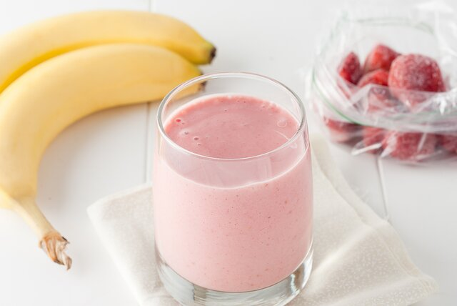

CREDIT: ZOEYTOJA/SHUTTERSTOCK

### Saturday

**Breakfast:**

* Frittata made with 3 large egg whites, 2 tablespoons diced bell peppers, 2 teaspoons chopped spinach, 2 tablespoons part-skim shredded mozzarella, and 2 teaspoons pesto 1/2 cup fresh raspberries
* 1 small bran muffin
* 1 cup skim milk

**Snack:**

* 1/2 cup low-fat vanilla yogurt with 1 tablespoon ground flaxseed and 1/2 cup diced pear

**Lunch:**

* 4 ounces sliced turkey breast
* Tomato-cucumber salad made with 5 slices tomato, 1/4 cup sliced cucumber, 1 teaspoon fresh chopped thyme, and 1 tablespoon fat-free Italian dressing
* 1 medium orange

**Snack:**

* Smoothie made with 3/4 cup skim milk, 1/2 banana, 1/2 cup low-fat yogurt, and 1/4 cup sliced strawberries (Psst: Here are more [weight loss smoothie ideas](https://www.shape.com/healthy-eating/healthy-drinks/4-smoothie-recipes-weight-loss).)

**Dinner:**

* 4 ounces red snapper baked with 1 teaspoon olive oil, 1 teaspoon lemon juice, and 1/2 teaspoon no-sodium seasoning
* 1 cup spaghetti squash with 1 teaspoon olive oil and 2 teaspoons grated Parmesan cheese
* 1 cup steamed green beans with 1 tablespoon slivered almonds

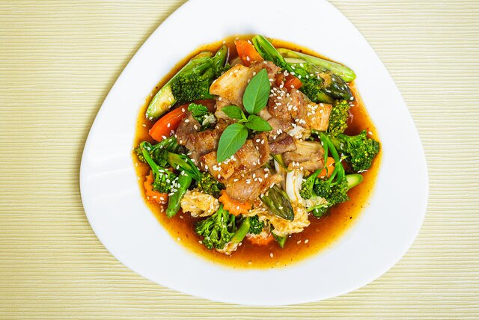

CREDIT: LITTLE/SHUTTERSTOCK

### Sunday

**Breakfast:**

* 2 slices Canadian bacon
* 1 whole-grain toaster waffle with sugar-free fruit spread
* 3/4 cup berries
* 1 cup skim milk

**Snack:**

* 1/4 cup fat-free cottage cheese with 1/4 cup cherries and 1 tablespoon slivered almonds

**Lunch:**

* Salad made with: 2 cups baby spinach, 4 ounces grilled chicken, 1 tablespoon chopped dried cranberries, 3 slices avocado, 1 tablespoon slivered walnuts, and 2 tablespoons low-fat vinaigrette
* 1 apple
* 1 cup skim milk

**Snack:**

* 1/4 cup plain fat-free Greek yogurt with 1 tablespoon sugar-free fruit spread and 1 tablespoon ground flaxseed
* 1/4 cup blueberries

**Dinner:**

* 4 ounces lean pork tenderloin stir-fried with onions, garlic, broccoli, and bell pepper
* 1/2 cup brown rice
* 5 medium tomato slices with 1 teaspoon each chopped ginger, chopped cilantro, light soy sauce, and rice wine vinegar